**PUBLIC HEALTH AWERNESS CAMPAIGN ANALYSIS**

**T MUTHARASU[812121106016]**



**INTRODUCTION:**

An effective public health awareness campaign plays a crucial role in educating and mobilizing communities to address various health-related issues. These campaigns are designed to inform, influence behaviour, and promote positive changes in individuals' and communities' health practices. This analysis will delve into the significance, goals, strategies, and impacts of public health awareness campaigns, highlighting their essential role in safeguarding the health and well-being of the population.

**OBJECTIVES:**

Assess Awareness Levels:

Measure the level of awareness about the health issue or topic before and after the campaign.

Determine how many people were reached by the campaign materials (e.g., through surveys, website analytics, or social media engagement).

Behavior Change:

Evaluate the extent to which the campaign influenced positive behavioral changes related to the health issue, such as increased vaccination rates, healthier lifestyle choices, or safer practices.

Compare the actual change in behavior to the desired outcomes outlined in the campaign goals.

Knowledge Gain:

Determine if the campaign increased public knowledge and understanding of the health issue, its causes, and potential solutions.

Conduct pre- and post-campaign surveys to gauge knowledge improvement.

Message Recall:

Evaluate the extent to which the campaign's key messages were remembered and retained by the target audience.

Analyze the effectiveness of various campaign channels (e.g., TV, radio, social media, posters) in conveying the messages.

Target Audience Engagement:

Measure the level of engagement with the campaign materials among the target audience (e.g., likes, shares, comments on social media posts, attendance at events, or website traffic).

Identify which elements of the campaign resonated most with the audience.

Assess Attitude Change:

Determine if the campaign positively influenced people's attitudes and perceptions related to the health issue.

Analyze changes in public perception, stigma reduction, or the willingness to seek treatment or preventive measures.

**DESIGN THINKING:**

Empathize:

Start by understanding the target audience for your public health awareness campaign. Who are they? What are their demographics, lifestyles, and behaviors?

Conduct surveys, interviews, and observations to gain insights into their attitudes, beliefs, and needs regarding the health issue you're addressing.

Create empathy maps and personas to consolidate the information you've gathered and build a deeper understanding of your audience.

Define:

Clearly define the problem you are trying to address with your campaign. What is the specific health issue or behavior change you aim to promote?

Create a problem statement that encapsulates the challenge you need to tackle.

Ideate:

Brainstorm creative ideas for your public health awareness campaign. Encourage a diverse team to generate a wide range of potential solutions.

Use ideation techniques like brainstorming, mind mapping, and storyboarding to explore different concepts and approaches.

Prototype:

Develop a prototype of your campaign concept. This can include creating mock-up materials, such as posters, brochures, social media content, or interactive experiences.

Keep in mind that the prototype doesn't need to be perfect; its purpose is to quickly convey the essence of your campaign idea.

Test:

Share your prototype with a small group of your target audience or stakeholders and gather feedback. Focus on their reactions, preferences, and suggestions.

Use this feedback to refine your campaign concept. Make necessary changes to improve its effectiveness and resonance with the audience.

Implement:

Once you've iterated and refined your campaign idea based on testing, it's time to fully implement it.

Plan and execute the distribution of campaign materials and activities.

Evaluate:

Continuously monitor and evaluate the impact of your public health awareness campaign. Collect data on awareness levels, behaviour change, and any other relevant metrics.

## C:\Users\MAMSE CSE\Downloads\3-Figure1-1.png

**DATASET:**

# DataPre-processing in R

Therearemanytoolsfordoingdatapre-processingavailable,suchasR,STATA,SAS,andPython;each differs in the level of programming background required. R is a free tool that is supported bya range of statistical and data manipulation packages. In this section of the chapter, we will gothrough some examples demonstrating various steps of data pre-processing in R, using data fromvarious MIMIC dataset (SQL extraction codes included). Due to the significant content involvedwith the data cleaning step of pre-processing, this step will be separately addressed in Chaps. 13and 14. The examples in this section will deal with some R basics as well as data integration,transformation,and reduction.

# R—TheBasics

The most common data output from a MIMIC database query is in the form of ‘comma separatedvalues’ files, with filenames ending in ‘.csv’. This output file formatcan be selected whenexporting the SQL query results from MIMIC database. Besides ‘.csv’ files, R is also able to readin other file formats, such as Excel, SAS, etc., butwewill not gointo the detail here.

# Understanding‘Data Types’ inR

Formanywhohaveusedotherdataanalysissoftwareorwhohaveaprogrammingbackground,youwill be familiar with the conceptof ‘data types’.

R strictly stores data in several different data types, called ‘classes’:Numeric– e.g. 3.1415, 1.618

Integer– e.g. -1, 0, 1, 2,3

Character – e.g. “vancomycin”, “metronidazole”Logical– TRUE, FALSE

Factors/categorical– e.g.male or femaleunder variable, gender

R also usually does not allow mixing of data types for a variable, except in a:List– as a onedimensional vector,e.g. c(“vancomycin”, 1.618, “red”)

Data-frame– asa two dimensionaltable withrows (observations) andcolumns (variables)

Listsand data-framesare treated astheir own ‘class’in R.

Query output from MIMIC commonly will be in the form of data tables with different data typesin different columns. Therefore, R usually stores these tables as ‘data-frames’ when they are readinto R.

SpecialValues in R

NA – ‘not available’, usually a default placeholder for missing values.NAN– ‘not a number’, only applying to numeric vectors.

NULL – ‘empty’ value or set. Often returned by expressions where the value is undefined.Inf– value for ‘infinity’ and only applies to numeric vectors.

SettingWorking Directory

This step tells R where to read in the source files.command:setwd(“directory_path”)

Example:(Ifalldatafilesaresavedindirectory“MIMIC_data_files”ontheDesktop)Reading in .csvFiles from MIMIC Query Results

ThedatareadintoRisassigneda‘name’forreferencelateron.Command:set_var_name<-read.csv(“filename.csv”)

## ViewingtheDataset

There are several commands in R that are very useful for getting a ‘feel’ of your datasets and seewhatthey look like before you start manipulating them.

* • Viewthe first and last 2 rows.E.g.:

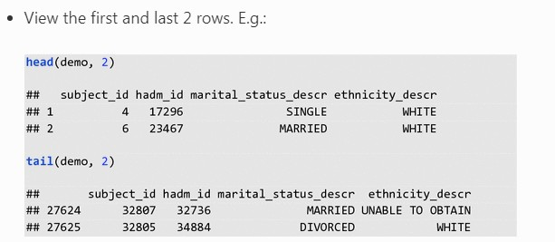

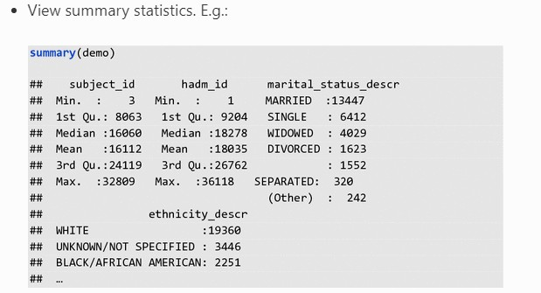

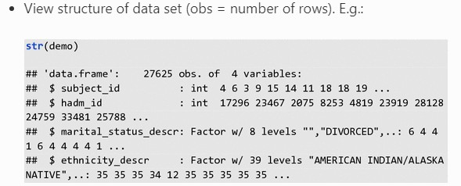

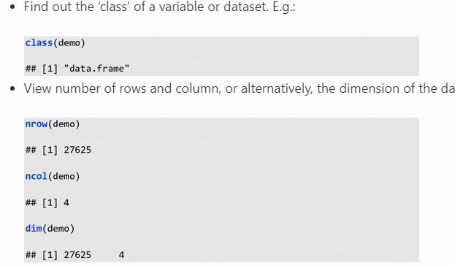

## Subsettinga Dataset andAdding New Variables/Columns

**Aim**:Sometimes,itmaybeusefultolookatonlysomecolumnsorsomerowsinadataset/data-frame—thisis called subsetting.

Let’screateasimpledata-frametodemonstratebasicsubsettingandothercommandfunctionsin

R. One simple way to do this is to create each column of the data-frame separately then combinethemintoadataframelater.Notethedifferentkindsofdatatypesforthecolumns/variablescreated,andbeware that R is case-sensitive.

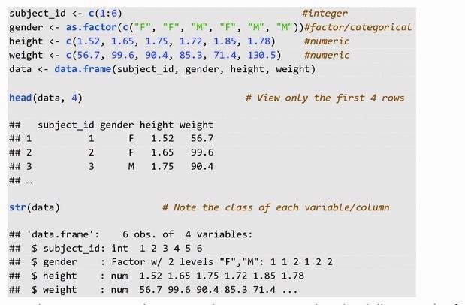

To subset or extract only e.g., weight, we can use either the dollar sign ($) after the dataset, data,orusethesquarebrackets,[].The$selectscolumnwiththecolumnname(withoutquotationmarkinthis case). The squarebrackets []here selectedthe column weight byits column number:

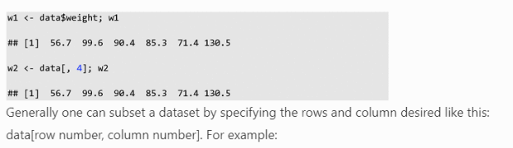

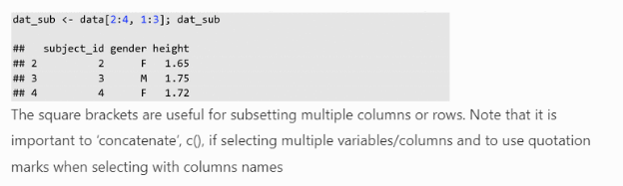

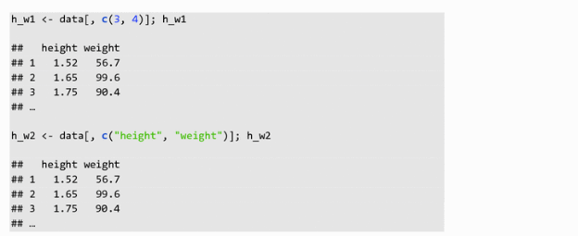

To calculate the BMI (weight/height^2) in a new column—there are different ways to do this buthereis a simple method:

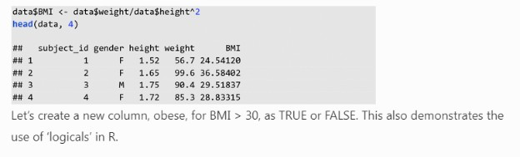

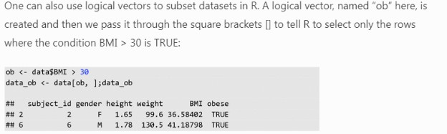

## CombiningDatasets (Called DataFrames in R)

**Aim**:Oftendifferentvariables(columns)ofinterestinaresearchquestionmaycomefromseparateMIMICtablesandcouldhavebeenexportedasseparate.csvfilesiftheywerenotmergedviaSQLqueries. For ease of analysis and visualization, it is often desirable to merge these separate dataframesin R on their shared ID column(s).

Occasionally, one may also want to attach rows from one data frame after rows from another. Inthis case, the column names and the number of columns of the two different datasets must be thesame.

**Examples**: In general, there are a couple ways of combining columns and rows from differentdatasets in R:

* •merge()—This function merges columns on shared ID column(s) between the dataframesso the associated rows match up correctly.

Command:merging on oneID column, e.g.:



Command:merging on two ID columns, e.g.:



* • cbind()—This function simply ‘add’ together the columns from two data frames(must have equal number of rows). Itdoes not matchup the rowsby any identifier.

Command:joining columns.E.g.:



* • rbind()—The function ‘row binds’ the two data frames vertically (must have the samecolumn names).

Command:joining rows. E.g.:



## UsingPackages in R

There are many packages that make life so much easier when manipulating data in R. They needto be installed on your computer and loaded at the start of your R script before you can call thefunctions in them. We will introduce examples of of a couple of useful packages later in thischapter.

Fornow, the command forinstalling packages is:



Thecommand for loadingthe package into theR working environment:



Note—there are no quotation marks when loading packages as compared to installing; you willget anerror message otherwise.

## GettingHelp in R

TherearevariousonlinetutorialsandQ&AforumsforgettinghelpinR.Stackoverflow,CranandQuick-Raresomegoodexamples.WithintheRconsole,aquestionmark,?,followedbythenameof the function of interestwill bring up the help menufor the function,e.g.



3.2Data Integration

**Aim**: This involves combining the separate output datasets exported from separate MIMICqueriesinto a consistent larger dataset table.

To ensure that the associated observations or rows from the two different datasets match up, therightcolumnIDmustbeused.InMIMIC,theIDcolumnscouldbesubject_id,hadm_id,icustay_id,itemid,etc.Hence,knowingthecontextofwhateachcolumnIDisusedtoidentifyandhow they are related to each other is important. For example, subject_id is used to identify eachindividual patient, so includes their date of birth (DOB), date of death (DOD) and various otherclinical detail and laboratory values in MIMIC. Likewise, the hospital admission ID, hadm_id, isused to specifically identify various events and outcomes from an unique hospital admission; andis also in turn associated with the subject_id of the patient who was involved in that particularhospital admission. Tables pulled from MIMIC can have one or more ID columns. The differenttables exported from MIMIC may share some ID columns, which allows us to ‘merge’ themtogether,matching up the rows correctlyusing the unique ID values intheir sharedID columns.

**Examples**: To demonstrate this with MIMIC data, a simple SQL query is constructed to extractsomedata, saved as: “population.csv” and “demographics.csv”.

Wewill these extracted files to showhow to mergedatasets in R.

1.1.

# SQLquery:

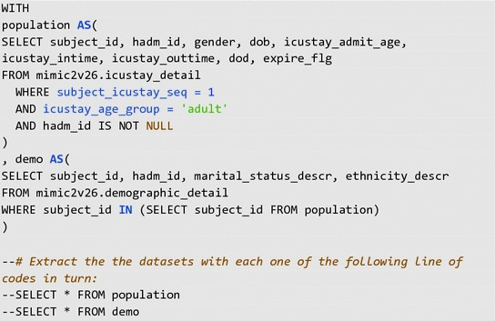

*Note:Remove the* -- *in front ofthe SELECT command to run the query.*

1.2.

# Rcode: Demonstrating data integration

Setworking directory andread data filesinto R::

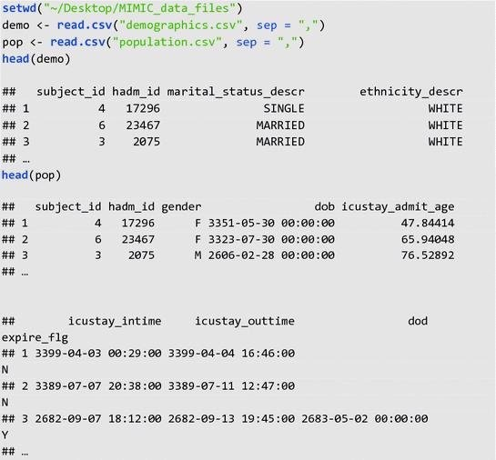

Merging pop and demo: Note to get the rows to match up correctly, we need to merge on both thesubject_id and hadm_id in this case. This is because each subject/patient could have multiplehadm_idfromdifferent hospital admissions during the EHR course of MIMIC database.

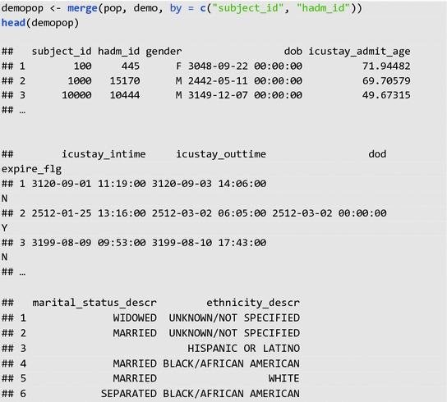

As you can see, there are still multiple problems with this merged database, for example, themissingvaluesfor‘marital_status_descr’column.DealingwithmissingdataisexploredinChap. [13.](https://doi.org/10.1007/978-3-319-43742-2_13)

# DataTransformation

**Aim**: To transform the presentation of data values in some ways so that the new format is moresuitable for the subsequent statistical analysis. The main processes involved are normalization,aggregationand generalization (Seepart 1 for explanation).

**Examples**: To demonstrate this with a MIMIC database example, let us look at a table generatedfromthe following simple SQL query, which we exported as “comorbidity_scores.csv”.

TheSQLqueryselectsallthepatientcomorbidityinformationfromthemimic2v26.comorbidity_scorestableontheconditionof(1)beinganadult,(2)inhis/herfirstICU

admission,and(3)wherethehadm_idisnotmissingaccordingtothemimic2v26.icustay_detailtable.

1.1.

# SQLquery:

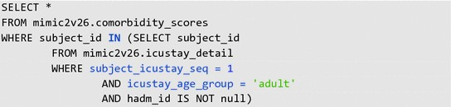

2.2.

# Rcode: Demonstrating data transformation:



Note the ‘class’ or data type of each column/variable and the total number of rows (obs) andcolumns(variables) in c_scores:

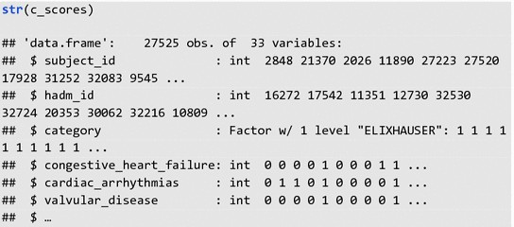

Here we add a column in c_scores to save the overall ELIXHAUSER. The rep() function in thiscase repeats 0 for nrow(c_scores) times. Function, colnames(), rename the new or last column,[ncol(c_scores)],as “ELIXHAUSER_overall”.



Takealook atthe result. Notethe new “ELIXHAUSER_overall” columnadded at theend:

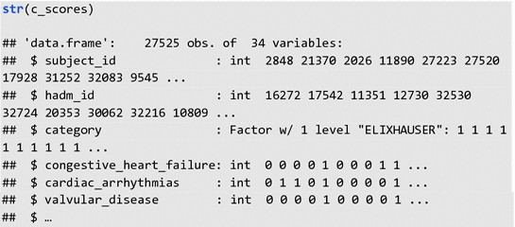

## AggregationStep

**Aim**: To sum up the values of all the ELIXHAUSER comorbidities across each row. Using a ‘forloop’, for each i-th row entry in column “ELIXHAUSER_overall”, we sum up all the comorbidityscores in thatrow.



Let’stake a look atthe head of theresultingfirstand lastcolumn:

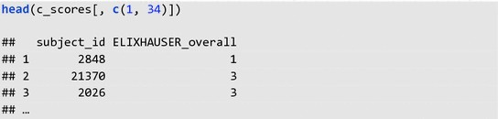

## NormalizationStep

**Aim**: Scale values in column ELIXHAUSER_overall to between 0 and 1, i.e. in [0, 1]. Function,max(),findsoutthemaximumvalueincolumnELIXHAUSER*overall.Wethenre*-*assigneach*

*entryincolumnELIXHAUSER*overallasaproportionofthemax_scoretonormalize/scalethecolumn.



We subset and remove all the columns in c_score, except for “subject_id”, “hadm_id”, and“ELIXHAUSER_overall”:

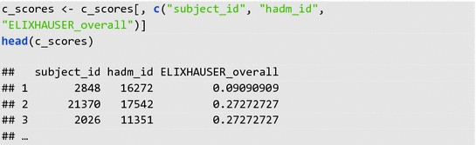

## GeneralizationStep

**Aim**: Consider only the patient sicker than the average Elixhauser score. The function, which(),return the row numbers (indices) of all the TRUE entries of the logical condition set on c_scoresinsidetheround()brackets,wheretheconditionbeingthecolumnentryforELIXHAUSER_overall ≥0.5. We store the row indices information in the vector, ‘sicker’. Thenwe can use ‘sicker’ to subset c_scores to select only the rows/patients who are ‘sicker’ and storethisinformation in ‘c_score_sicker’.

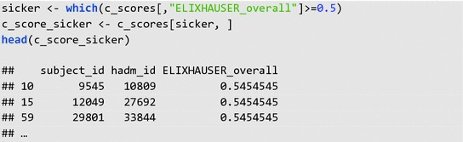

Saving the results to file: There are several functions that will do this, e.g. write.table() andwrite.csv().Wewill give an examplehere:



Ifyou check inyour working directory/folder,you should see thenew “c_score_sicker.csv”file.

3.4Data Reduction

**Aim**:Toreduceorreshapetheinputdatabymeansofamoreeffectiverepresentationofthedatasetwithoutcompromisingtheintegrityoftheoriginaldata.Oneelementofdatareductioniseliminatingredundantrecordswhilepreservingneededdata,whichwewilldemonstrateinExample Part 1. The other element involves reshaping the dataset into a “tidy” format, which wewilldemonstrate in below sections.

## ExamplesPart 1: Eliminating Redundant Records

To demonstrate this with a MIMIC database example, we will look at multiple records of non-invasivemeanarterialpressure(MAP)foreachpatient.WewillusetherecordsfromthefollowingSQLquery, which we exported as “mean_arterial_pressure.csv”.

The SQL query selects all the patient subject_id’s and noninvasive mean arterial pressure (MAP)measurements from the mimic2v26.chartevents table on the condition of (1) being an adult, (2) inhis/herfirstICUadmission,and(3)wherethehadm_idisnotmissingaccordingtothemimic2v26.icustay_detailtable.

1.1.

# SQLquery:

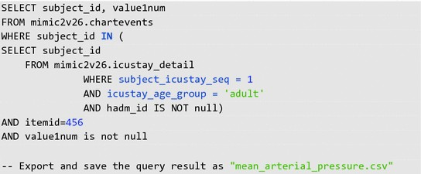

**Rcode**:

Thereareavarietyofmethodsthatcanbechosentoaggregaterecords.Inthiscasewewilllookataveraging multiple MAP records into a single average MAP for each patient. Other options whichmaybe chosen include usingthe first recorded value, aminimum or maximum value,etc.

For a basic example, the following code demonstrates data reduction by averaging all of themultiplerecords of MAPintoasingle record perpatient. The code usestheaggregate() function:

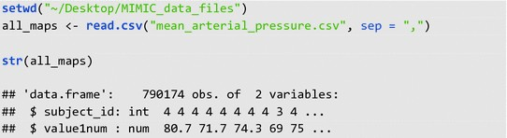

Thisstep averages theMAP values foreach distinctsubject_id:

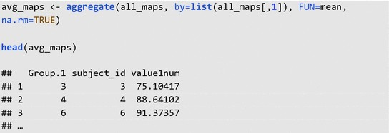

## ExamplesPart 2:Reshaping Dataset

**Aim**:Ideally,wewanta“tidy”datasetreorganizedin suchawaysoitfollows these3 rules[[2,](https://link.springer.com/chapter/10.1007/978-3-319-43742-2_12#ref-CR2)[3]](https://link.springer.com/chapter/10.1007/978-3-319-43742-2_12#ref-CR3):

1. 1.

Each variable forms a columnEach observation forms a row2.3.

Eachvalue has its own cell

Datasets exported from MIMIC usually are fairly “tidy” already. Therefore, we will construct ourown data frame here for ease of demonstration for rule 3. We will also demonstrate how to usesomecommon data tidying packages.

**R code**: To mirror our own MIMIC dataframe, we construct a dataset with a column of subject_idanda column with a list of diagnoses for the admission.

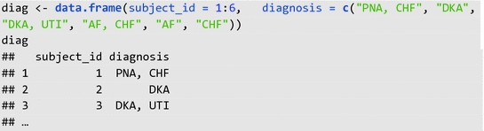

Note that the dataset above is not “tidy”. There are multiple categorical variables in column“diagnosis”—breaks “tidy” data rule 1. There are multiple values in column “diagnosis”—breaks“tidy”data rule 3.

Therearemanywaysto“tidy”andreshapethisdataset.Wewillshowonewaytodothisbymakinguse of R packages “splitstackshape” [[5]](https://link.springer.com/chapter/10.1007/978-3-319-43742-2_12#ref-CR5)and “tidyr” [[4]](https://link.springer.com/chapter/10.1007/978-3-319-43742-2_12#ref-CR4) to makereshaping the dataset easier.

# Rpackage example 1—“splitstackshape”:

Installingand loadingthe package intoR console.



The function, cSplit(), can split the multiple categorical values in each cell of column “diagnosis”into different columns, “diagnosis_1” and “diagnosis_2”. If the argument, direction, for cSplit() isnotspecified, then the function splits theoriginal dataset “wide”.

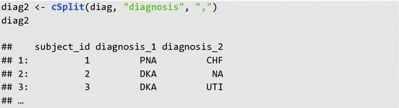

One could possibly keep it as this if one is interested in primary and secondary diagnoses (thoughitis not strictly “tidy” yet).

Alternatively, if the direction argument is specified as “long”, then cSplit split the function “long”likeso:

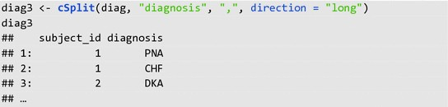

Notediag3isstillnot“tidy”astherearestillmultiplecategoricalvariablesundercolumndiagnosis—butwe no longer have multiple values per cell.

# R packageexample 2—“tidyr”:

Tofurther “tidy”the dataset,package “tidyr”is prettyuseful.



The aim is to split each categorical variable under column, diagnosis, into their own columns with1 = having the diagnosis and 0 = not having the diagnosis. To do this we first construct a thirdcolumn, “yes”, that hold all the 1 values initially (because the function we are going use require avaluecolumn thatcorrespond with the multiple categories column we want to‘spread’ out).

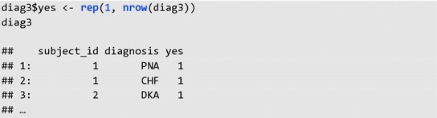

Then we can use the spread function to split each categorical variables into their own columns.Theargument, fill = 0, replaces the missing values.

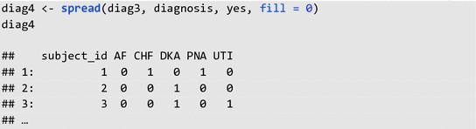

Onecan see that this datasetis now “tidy”, as itfollows all three“tidy” datarules.

**Feature engineering:**

Feature engineering in the context of public health awareness involves selecting and creating relevant variables or features to better understand, measure, and address public health issues. These features can help public health professionals and researchers to make informed decisions, develop effective interventions, and communicate vital information to the public. Here are some key features that can be engineered to promote public health awareness

Demographic Data: Collect demographic information such as age, gender, race, and socioeconomic status to understand disparities in health outcomes.

**Geospatial Data:** Utilize geographic information systems (GIS) to map disease prevalence, healthcare resources, and areas with health disparities. This can help identify high-risk areas and target interventions accordingly.

**Health Behaviors**: Create features to track health-related behaviors, such as smoking, diet, exercise, and substance abuse, to identify patterns and areas where interventions are needed.

**Social Determinants of Health:** Incorporate data on education, employment, housing, and neighborhood conditions to assess how these factors impact public health outcomes.

**Environmental Factors**: Consider features related to air and water quality, exposure to toxins, and climate-related variables to understand their impact on health.

**Healthcare Access**: Create features to analyze the availability and accessibility of healthcare services, including the number of hospitals, clinics, and healthcare providers per capita.

**Epidemiological Data**: Feature engineering can involve creating variables related to disease prevalence, incidence, mortality rates, and the spread of infectious diseases.

**Social Media and Online Engagement**: Analyze data from social media and online sources to gauge public sentiment, awareness, and information dissemination related to public health topics.

**Vaccination Coverage:** Track vaccination rates and create features to identify regions or populations with lower immunization rates.

**Emergency Response Readiness:** Assess the preparedness of communities and healthcare facilities in responding to public health emergencies or disasters.

**Healthcare Utilization**: Develop features related to hospital admissions, emergency room visits, and healthcare utilization patterns to identify trends and allocate resources more effectively.

**Media and Communication Data:** Incorporate features related to media coverage and public health campaigns, including the reach and impact of public health awareness campaigns.

**Model evaluation:**

Evaluating public health awareness campaigns is crucial to determine their effectiveness in achieving their goals, which may include raising awareness about a specific health issue, promoting healthy behaviors, or encouraging people to seek medical care when necessary. Here are some key steps and considerations for evaluating public health awareness campaigns in the context of public health

**Define Clear Objectives and Goals:**

Clearly define the objectives of your public health awareness campaign. What specific behavior or knowledge are you trying to promote or change? Set measurable goals to assess success.

**Identify Key Performance Indicators (KPIs):**

Determine the KPIs that will help you measure the campaign's success. These might include metrics like website visits, social media engagement, changes in behavior or attitudes, or increased uptake of health services.

**Baseline Data Collection:**

Collect baseline data on the health issue or behavior you're targeting before launching the campaign. This data will serve as a reference point for measuring the campaign's impact.

**Monitor and Measure:**

Continuously monitor and measure the selected KPIs throughout the campaign. Tools such as surveys, website analytics, social media metrics, and focus groups can help assess the impact.

**Surveys and Feedback:**

Conduct surveys and gather feedback from the target audience to assess changes in awareness, knowledge, attitudes, and behaviors related to the public health issue.

**Message Recall and Reach:**

Measure the campaign's reach and how well the target audience recalls and understands the campaign messages.

**Behavior Change:**

Evaluate changes in behavior or attitudes related to the health issue. For example, if the campaign is about smoking cessation, assess the number of people who have quit smoking or reduced their consumption.

**Health Outcome Indicators:**

Examine health outcome indicators to assess if the campaign has resulted in better health outcomes. This could include changes in disease incidence or reduction in risk factors.

**Cost-Effectiveness:**

Evaluate the cost-effectiveness of the campaign, comparing the resources invested to the outcomes achieved.

**Qualitative Assessment:**

Qualitative research methods, such as focus groups and in-depth interviews, can provide valuable insights into how the campaign is perceived and whether it is effectively reaching the intended audience.

**Post-Campaign Surveys:**

After the campaign, conduct follow-up surveys and evaluations to assess the long-term impact and sustainability of behavior change.

**Comparative Analysis:**

Compare the results of the campaign to similar campaigns or initiatives in the past to identify areas for improvement and best practices.

**Adjust and Improve:**

Based on the evaluation results, make necessary adjustments to the campaign to improve its effectiveness.

**Reporting and Communication:**

Share the evaluation findings with stakeholders, including the public, funders, and relevant authorities. Transparent reporting can build trust and support for future campaigns.

**Iterative Process:**

Public health awareness campaigns should be viewed as an iterative process. Learning from past campaigns and continually improving strategies is essential for long-term success.

Remember that effective evaluation is an ongoing process, and it's essential to adapt your approach based on the campaign's goals and target audience. By carefully evaluating your public health awareness campaign, you can ensure that it is achieving its intended impact and contributing to improved public health outcomes.

**Visualization:**

Visualization plays a crucial role in public health awareness campaigns. Well-designed visuals can effectively convey complex information and raise awareness about various health issues, helping to educate and engage the public. Here are some ways visualization is used in public health awareness.

**Infographics:**Infographics are a popular tool for presenting health information in a visually appealing and easy-to-understand format. They can include statistics, charts, and concise text to convey key messages about health issues, preventive measures, and treatment options.

**Maps:** Geographic information system (GIS) maps can show the spread of diseases, the prevalence of health issues in different regions, and the availability of healthcare resources. Mapping helps policymakers and the public understand the spatial aspects of public health challenges.

**Charts and Graphs:** Visualizing data through bar charts, line graphs, pie charts, and scatterplots helps make statistics more accessible. These visualizations can illustrate trends, risk factors, and the impact of interventions.

**Interactive Dashboards:** Creating online dashboards that allow users to explore health data interactively can be a powerful tool. Users can customize the view and gain insights by interacting with the data.

**Social Media Graphics:** Visuals are highly shareable on social media platforms, making them an effective tool for public health awareness campaigns. Short, impactful graphics or videos can quickly spread information and promote healthy behaviors.

**Videos and Animations**: Animated videos can simplify complex health concepts, illustrate proper hygiene practices, and describe the impact of certain behaviors on health. They are engaging and memorable.

**Photography:** Powerful images can convey the human side of public health issues. Photos of patients, healthcare workers, and the impact of diseases can create an emotional connection with the audience.

**Campaign Posters:** Traditional posters and billboards remain effective for reaching a broad audience. They should use compelling visuals and concise messages to encourage healthy behaviors or promote awareness.

**Storytelling:** Storytelling through visuals, such as comics or graphic novels, can be used to create relatable characters and narratives that educate people about health issues.

**Data Visualization Tools:** Data visualization software allows public health professionals to create customized charts, maps, and graphs for their specific needs. Tools like Tableau, Power BI, and D3.js are commonly used.

**Epidemiological Models:** During disease outbreaks, visualizations of epidemiological models can help the public understand the spread of the disease, the importance of social distancing, and vaccination efforts.

**Health Promotion Campaigns**: Visuals are key in promoting health behaviors like smoking cessation, healthy eating, and exercise. These campaigns often use striking imagery and simple, memorable slogans.

**Behavior Change Models:** Visuals can explain models like the Health Belief Model or the Transtheoretical Model, which help individuals understand their own health behaviors and how to make positive changes.

When creating visualizations for public health awareness, it's essential to consider the target audience, their level of health literacy, and cultural sensitivities. Additionally, the information should be accurate and evidence-based. Collaboration between public health experts, graphic designers, and communication professionals is often necessary to create effective and impactful visuals.

**PROGRAM:**

import pandas as pd

importmatplotlib.pyplot as plt

importseaborn as sns

# Load data from a CSV file

data = pd.read_csv('campaign_data.csv')

print(data.head())

print(data.info())

data['CTR'] = (data['clicks'] / data['impressions']) * 100

data['Conversion Rate'] = (data['conversions'] / data['clicks']) * 100

# Create subplots for visualizing the data

plt.figure(figsize=(12, 6))

plt.subplot(1, 2, 1)

sns.barplot(x='campaign_name', y='CTR', data=data)

plt.title('Click-Through Rate (CTR) by Campaign')

plt.subplot(1, 2, 2)

sns.barplot(x='campaign_name', y='Conversion Rate', data=data)

plt.title('Conversion Rate by Campaign')

plt.tight_layout()

plt.show()

summary_stats = data.groupby('campaign_name')[['impressions', 'clicks', 'conversions', 'CTR', 'Conversion Rate']].mean()

print(summary_stats)

**OUTPUT:**

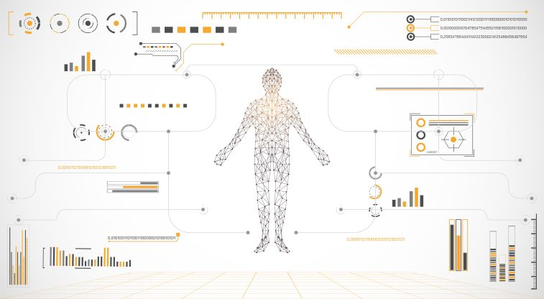

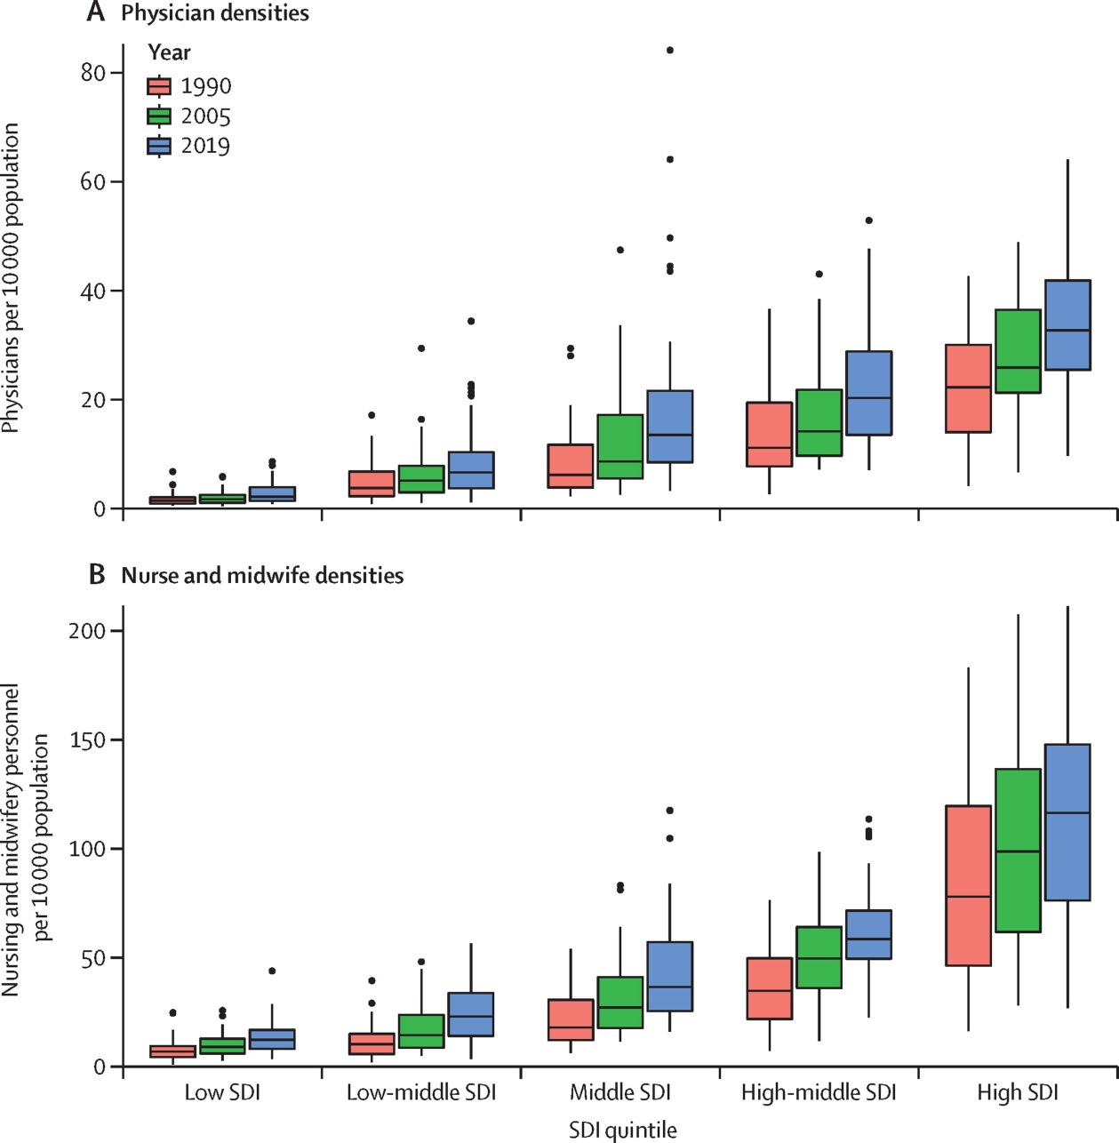

**CONCLUSION:**

Effectiveness in Raising Awareness: The campaign successfully increased awareness about the health issue(s) it aimed to address. [Provide data or evidence of increased awareness, if available.]

Behavioral Change: There is evidence to suggest that the campaign has influenced positive changes in health-related behaviors among the target audience. [Include specific examples and data if applicable.]

Community Engagement: The campaign effectively engaged with the community, involving key stakeholders, organizations, and individuals in the campaign's activities and initiatives.

Media and Communication Strategies: The choice of communication channels and media was appropriate for the target audience. The campaign's use of social media, traditional media, and community events contributed to its success.

Message Clarity and Relevance: The campaign's messages were clear, concise, and resonated with the audience, making them more likely to remember and act upon the information.

Long-Term Impact: There is evidence to suggest that the campaign has had a positive long-term impact on public health outcomes. [Include relevant data or trends that support this conclusion.]

Challenges and Lessons Learned: The campaign also faced certain challenges, such as [mention challenges], which offer valuable lessons for future public health awareness initiatives.

In light of these conclusions, we recommend the following for future public health awareness campaigns:

Sustain and Expand: It is crucial to sustain the momentum of the campaign's success and consider expanding its reach to additional demographics or regions.

Continuous Evaluation: Implement a systematic process for ongoing evaluation to monitor the campaign's impact and adjust strategies as needed.

Leverage Partnerships: Collaborate with community organizations, health professionals, and government agencies to enhance the campaign's reach and effectiveness.

Tailored Messaging: Continue to develop and refine messages that resonate with the target audience, taking into account their specific needs and preferences.

Utilize Data and Technology: Harness data analytics and technology to optimize campaign targeting and delivery, making the best use of resources.

In conclusion, the [Campaign Name] has made significant strides in raising awareness and promoting positive health-related behaviors within the community. The insights gained from this analysis will serve as a foundation for future public health awareness campaigns, ensuring that they are even more impactful and effective in improving public health outcomes. The commitment to public health awareness remains a cornerstone of our efforts to create healthier communities and a better quality of life for all.